- Using the fin template as a guide, carefully cut out three fins for your rocket from a paper or plastic file folder. Please try to conserve materials.
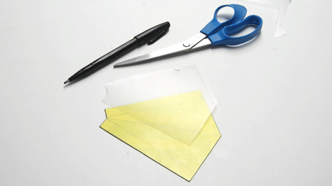
- Fold the fins along the internal lines.
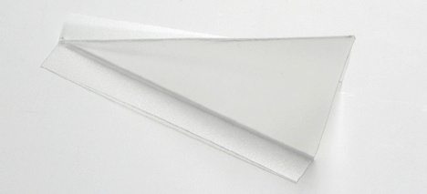
- Tape the fins to the rocket, spacing them in even thirds around the bottle. 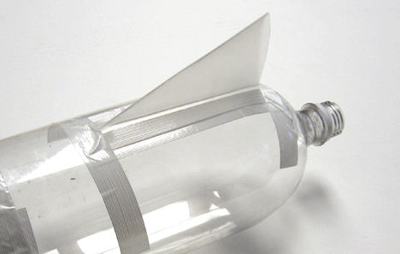
- Tape tennis ball to top of rocket. Note that the picture is of a two-bottle design
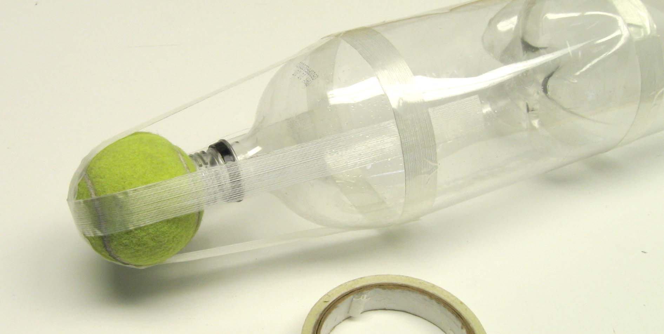

Instructions: Steps one through four in the left panel describe a suggested rocket design. You are not required to use this design as long as your rocket conforms to the following six points.

- Rockets must use a one-liter or two-liter bottle as their main chamber.

- Rocket bottles must be designed for soda or other carbonated beverage.

- Rocket bottles must be undamaged.

- Rocket bottles must be clean of all debris and dirt.

- No metal, rocks or heavy plastic may be used on any part of the rocket.

- The rocket must not have any sharp points.

IMPORTANT: Rockets will be inspected before launch. Rockets that do not conform to the six points listed above will not be allowed to launch. BE Careful not to damage bottle during construction!

Hints: The following four hints can be used to improve the performance of your rocket.

- Make sure everything on your rocket is neat and straight.

- Place your tennis ball farther forward on your rocket to make your rocket more stable. To do this you will need to add material or a second bottle.

- Move your fins further back on your rocket to make your rocket more stable. This is difficult. Be creative.

- Make a nose cone to reduce the drag on your rocket.

